**Semester: V Name of Student:**

**Academic Year: 2022-23 Student ID:**

**Class / Branch: TE IT**

**Subject: Advanced Devops Lab (ADL)**

**Name of Instructor:Prof. Manjusha K.**

**EXPERIMENT NO. 05**

**Aim: To understand terraform lifecycle, core concepts/terminologies and install it on a Linux Machine.**

**Terraform Installation Steps on Ubunu18.04**

**Step: 1** Terraform uses HashiCorp Configuration Language (HCL) to manage environments of Operators and Infrastructure teams. To download go to site <https://www.terraform.io/downloads.html>

Select the appropriate package for your operating system and architecture.

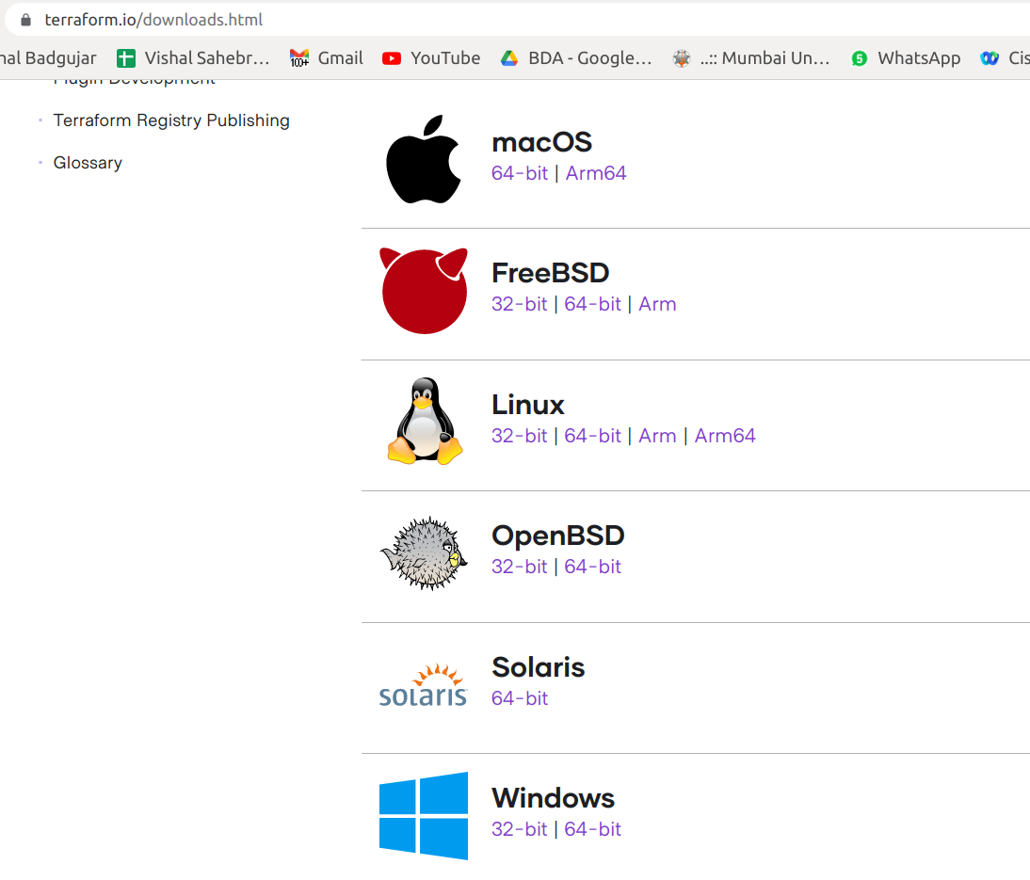

**Step:2** unzip the archive by using below command



The archive will extract a single binary called **terraform**.

Step 3: Change the directory to unzipped folder

and Move the terraform binary to a directory included in your system's PATH in my case *usr/*local/bin/



**Step 4:** To check whether Terraform is installed, run:

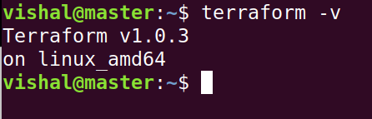

**Conclusion: Write your own findings.**